Sprint 3 Materials

Equipo Grande



Anthony Bragg

Juliana Leano

Caroline Mejia

Daniel Morrison

Christopher Weeks

# Retrospective Summary

Sprint 3 went very well for us. We overestimated how many points our backlog items were worth, so we completed many points very quickly. This is because we did not experience nearly as many hurdles as we had in previous sprints such as extensive learning curves, so we were mostly done with our sprint items on day 1.

Because the majority of our user stories were mostly complete, we were able to spend time collecting more user feedback and use this feedback to spend more time polishing our final product. The extra time we had also allowed us to be able to implement a few of our stretch goals: product pairs trends and charts for every trend.

In the future, if we were to continue, we should reassess how many points each backlog item is worth and add more tasks to our backlog because many of our user stories were completed much sooner than our estimates. Also, we feel like because we were more focused and familiar with the resources needed during sprint 3, we had less motivation to give the stand up meeting the time and priority it deserved.

# GitHub Release Link:

[Insert GitHub Link Here]

# Product Backlog

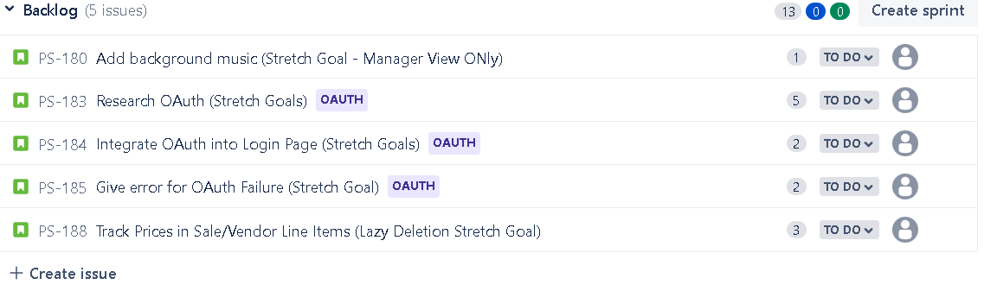

Sprint Backlog

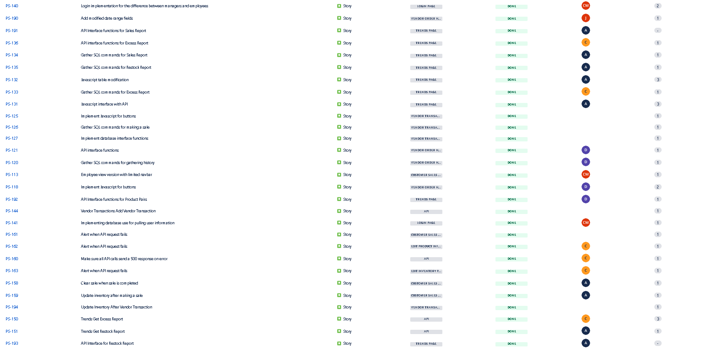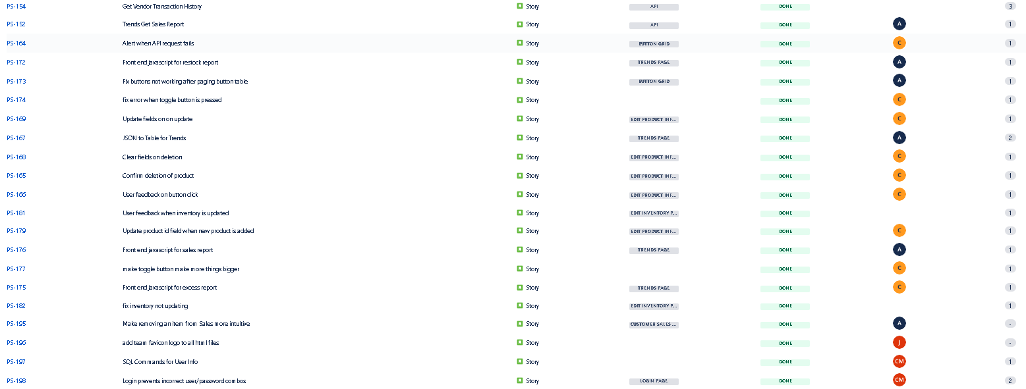

| Anthony | 17 |
| --- | --- |
| Juliana | 9 |
| Caroline | 7 |
| Daniel | 8 |
| Chris | 17 |

# Burn-down Charts

Sprint 3 Burndown Chart

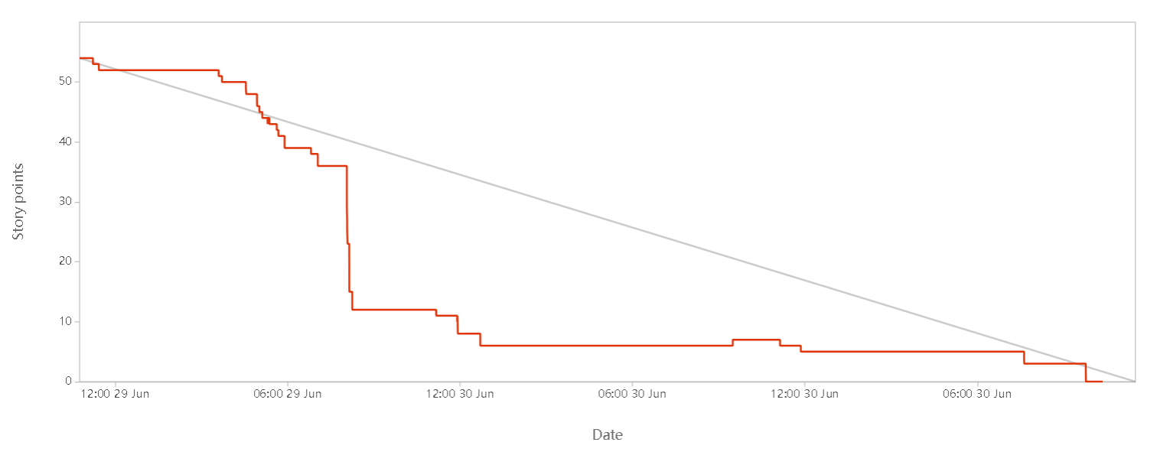

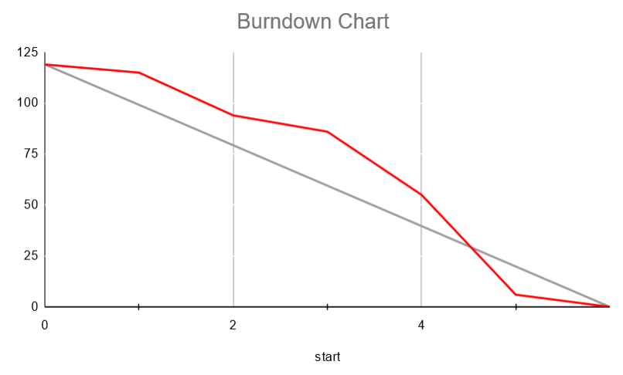

Appendix 1: SCRUM Meeting Agendas and Minutes

SCRUM Meeting 1 for Project 3

Prepared by: Daniel Morrison

Meeting Date: 6/29/2022

## Meeting Attendees

1. Anthony Bragg
2. Juliana Leano
3. Caroline Mejia
4. Daniel Morrison
5. Christopher Weeks

## Meeting Agenda Items

* Assign tasks for Sprint 3
* Prepare to begin Sprint 3

## Status Update Since Last Meeting

Accomplishments:

* We finished Sprint 2:
  + Implemented front end for vendor history, vendor transaction and trends
  + Implemented backend API for make sale, edit inventory and edit products
  + Made features such as Accessibility mode consistent across pages
  + Fixed visual errors and inconsistencies
  + Implemented user feedback from user interviews

Tasks Completed:

| **Task Description** | **Assigned to** | **Completed? (yes/no)** |
| --- | --- | --- |
| Create a different interface for manager / cashier | Juliana | No |
| Update sales page with a quantity indicator | Daniel | Yes |
| Write Node.js and SQL commands for sales | Anthony | Yes |
| Created limited navbar for employee view | Caroline | No |
| Finish trends page (sidebar, graph, etc.) | Caroline | Yes |
| Finish HTML/Bootstrap for Vendor Transactions | Juliana | Yes |
| Update manager navbar with new page tabs | Caroline | Yes |
| Write Node.js and SQL commands for Edit Product page | Chris | Yes |
| Write Node.js and SQL commands for Edit Inventory page | Daniel | Yes |
| Change number of rows/columns of buttons for accessibility view | Daniel | Yes |
| Make button size persist between pages | Daniel | Yes |
| Finish API for Products | Chris | Yes |
| Write API for Inventory | Daniel | Yes |
| Write API for Sales | Anthony | Yes |
| Interface with API for Products | Chris | Yes |
| Interface with API for Sales | Anthony | Yes |
| Interface with API for Inventory | Daniel | Yes |

## Before The Next Meeting

Plans:

* Polish sprint 2 items
* Create API calls for the various trends reports and vendor history
* Create differences from manager view and employee view;

Task Assignments:

| **Task Description** | **Assigned to** |
| --- | --- |
| Create separation of manager view and employee view | Caroline and Juliana |
| Vendor Order History functionality | Daniel |
| Excess Report back-end functionality | Chris |
| Restock Report back-end functionality | Anthony |
| Sales Report back-end functionality | Anthony |
| Finish login implementation | Juliana |
| Figure out how to turn a JSON object into a table | Daniel |
| Add user feedback, visual consistencies | All members |
| Fix existing bugs and polish Sprint 2 items | All members |

## Minutes from Previous Meeting

In our last meeting we discussed the final necessary tasks for Sprint 2 and assigned them to team members for completion, specifically discussing API calls and their learning curves, the new pages that had to be laid out, and other minor consistencies and viewing details to be fixed.

SCRUM Meeting 2 for Project 3

Prepared by: Daniel Morrison

Meeting Date: 6/30/2022

## Meeting Attendees

1. Anthony Bragg
2. Juliana Leano
3. Caroline Mejia
4. Daniel Morrison
5. Chris Weeks

## Meeting Agenda Items

* Assign remaining tasks for Sprint 3
* Begin work on product presentation

## Status Update Since Last Meeting

Accomplishments:

* Achieved all page functionalities except for the Trends page
* Due to User Feedback, cleaned up a lot of usability hiccups

Tasks Completed:

| **Task Description** | **Assigned to** | **Completed? (yes/no)** |
| --- | --- | --- |
| Create separation of manager view and employee view | Caroline and Juliana | no |
| Vendor Order History functionality | Daniel | yes |
| Excess Report back-end functionality | Chris | yes |
| Restock Report back-end functionality | Anthony | yes |
| Sales Report back-end functionality | Anthony | yes |
| Finish login implementation | Juliana | no |
| Figure out how to turn a JSON object into a table | Anthony | yes |
| Add user feedback, visual consistencies | All members | yes |
| Fix existing bugs and polish Sprint 2 items | All members | yes |

## Before The Next Meeting

Plans:

* Finish Trends page and make it usable
* Continue to integrate and polish the entire product

Task Assignments:

| **Task Description** | **Assigned to** |
| --- | --- |
| Finish implementing employee v. manager designation | Juliana |
| Create separation of manager view and employee view | Caroline |
| Polish API errors | Chris |
| Make product pairs API | Anthony and Daniel |
| Make front end for Product Pairs | Anthony and Daniel |
| Make code more readable | All members |
| Make all reports function correctly on the Trends Page | All members |
| Fix existing bugs and polish product | All members |

## Minutes from Previous Meeting

In our last meeting we began assigning tasks for sprint 3 and diving into the final section of our project. Specifically, we focused on writing and completing the 3 pages of Trends, Vendor Transactions, and Vendor History.